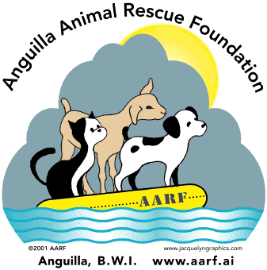 | The Anguilla Animal Rescue Foundation  Membership Form
Annual Fees
(Please check one) EC$ US$
______ Student (Under age 18) $ 13.00 $ 5.00
______ Regular $ 53.00 $ 20.00
______ Senior (65 and over) $ 13.00 $ 5.00
______ Family $ 80.00 $ 30.00
______ Corporate $300.00 $112.00
Fee Paid One Time (Per Individual):
______ Lifetime EC$500.00/US$186.00
Please accept my additional donation of $___________ to help the animals of Anguilla.
Receipt Required: _____ Yes ____ No

Last Name: ________________________ First Name(s): _______________________
Address: __________________________ PO Box: ____________________________
City: ______________________________ State (US Residents): __________________
Zip/Country Code: ______________ Country: ____________________________
Phone: _______________________ Email: ______________________________
Signature: ______________________
Please make check or money order payable to Anguilla Animal Rescue Foundation and mail this form and your payment to the following address:
The Anguilla Animal Rescue Foundation
PO BOX RI 4228
Anguilla, BWI
264-476-2731

Amount Paid: _______________ Cash: ____________ Check #: _______________ Date: ____________

8.12.09

