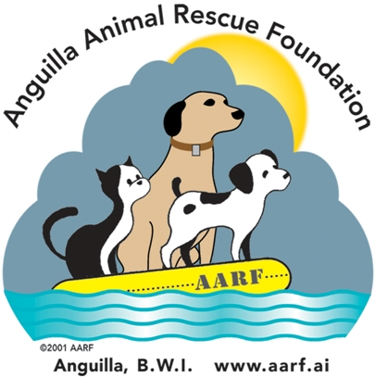
Duke of Edinburgh's Award Program - Anguilla

Dear Student,
On behalf of the Anguilla Animal Rescue Foundation, I would like to welcome you to the volunteer program at the AARF Shelter! Opened in January of 2008, AARF depends solely on volunteers to take care of socializing, cleaning, and caring for the homeless and unwanted puppies and kittens, and even adult dogs and cats that come to our shelter.
Shelter Hours:
Monday to Friday: 9 – 11:30 or 2:45 – 4:45
Saturday: 9 – 11:30

We have been asked by the staff at Morlens to make sure our duties are finished by their closing time. I believe your program requires an hour of volunteering each time – however, if you have more time we would certainly appreciate your help. I just ask that you plan your time at the shelter so you can be ready to leave when volunteer hours are over. Please make sure you sign in each time you volunteer – there is a clipboard on the shelter desk located on the left of the entrance to the clinic/shelter.
One of the main questions asked about the DEAA program at AARF is what am I expected to do while at the clinic? You may find that some of the things we are expected to do are not much fun, but they are as important as the “fun” things!

Duties of Shelter Volunteers
• Clean kennels – This is probably the least popular and most important duty of the volunteers. The staff at Morlens is paid fees by AARF which include feeding the animals and cleaning their kennels in the morning. While the volunteers are at the shelter we check regularly for any additional messes and then clean those promptly and put in fresh newspaper – it’s a frequent job especially when we have puppies!
Plastic gloves are provided for clean up as well as paper towels and you are asked to wear them when doing clean up to avoid spreading germs. Plastic garbage bins are available for soiled newspapers & paper towels.
We let the puppies out of their kennels for some exercise and play time but only those in the same kennel should be allowed out at the same time – that way we can hopefully keep any illnesses from spreading to another litter. Most of the animals that come into the shelter haven’t been vaccinated and are thus more susceptible to germs and diseases especially the puppies that can spread germs to one another by walking in contaminated fecal matter – another important reason to keep their kennels clean. The puppies and kittens do not carry any diseases that can be transmitted to people – just to each other.
• Walk dogs – We walk the dogs as often as we can so that they can stretch & exercise, get some fresh air, & relieve themselves. Dogs will not potty in or near their living quarters unless forced to, so we try to take them out as much as possible. A big part of the walking is also socialization. Some of the dogs are shy or skittish and we work with them so that they are more comfortable and will be more adoptable. If you are not comfortable taking dogs for a walk then please do not feel obligated to do so. We are not allowed to walk the dogs on either lane to the East or to the West of the shelter – many of our guests enjoy walks down to Sandy Hill Bay and the Morlens staff will be happy to show you where that walk is. We also have a path across the road in the AARF parking lot that goes into the bush. The dogs need to be kept on their leashes at all times.
• Socialize puppies & kittens & cats – While these don’t need to be walked, they do need socialization. It’s important for the volunteers to help all shelter animals become as comfortable with people as possible, thereby improving their chances for successful adoptions. Sometimes just sitting and holding a puppy or kitten can make the difference in his/her adoption which is why this is so important.
If you are the only volunteer that day then it would be very helpful if you emailed me if possible after your shift to let me know what if anything including adoptions or surrenders happened that day. If that is not possible I understand, but I would like to hear from you if you have a chance.
Since the AARF Shelter is part of Morlens Veterinary Clinic, volunteers often see Morlens clients come in for treatment. It’s very important to respect the privacy and confidentiality of all activities of which we become aware. Dr Rommel Umali is the veterinarian you will most often see at the clinic. Jaicus is the clinic attendant who is happy to answer any questions you might have if an AARF volunteer is not available. Since we are very short of volunteers you will probably work more often will Jaicus although in the winter months we do occasionally have afternoon volunteers who will be happy for your help. We hope that you will want to continue volunteering after your commitment has been met as you are always welcome and needed at the AARF Shelter!
As the shelter manager (also a volunteer) I can’t begin to tell you how much your interest and your help is appreciated not only by the other volunteers but also by the shelter guests! Please feel free to email me at axasuzie@anguillanet.com if you have any questions or concerns regarding our program. I hope that through this experience you will learn that volunteering is a very important part of life – it not only gives to others, but the personal rewards, which include satisfaction and friendship, are priceless. I look forward to meeting each of you.
Thank you - Suzie Donahue - AARF Shelter Manager

